
EBSCO eBook Workflow
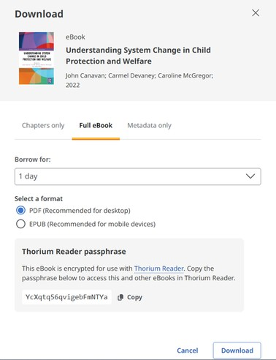





- Ensure Thorium Reader is available on the device.
- Sign into MyEBSCO (required for DRM)
- Search for an eBook, click download (full eBook)
- Select borrow time/format if applicable
- Copy passphrase
- Click download
- Open the file in Thorium Reader (you will need to enter the passphrase when prompted)

Watch a screencast here!

Supporting documentation:
FAQguide
New DRM solution
EBSCO eBooks LibGuide
Download Thorium
Thorium Accessibility
Thorium support
Supported apps
Forgot your Thorium passphrase?
Note: You must copy the passphrase before downloading the file. The downloaded eBook is tied to that passphrase. If you forget your passphrase you must generate a new one and re-download the eBook.




Customer Training Services
https://connect.ebsco.com/s/academy customersuccess@ebsco.com

